**Standing Power Throw**

**Submitted By:**

Lourdes Barragan- Analysis and Design

Rene Aleman- Development and Storyboarding

Liela Shadmani- Subject Matter Expert, Content Knowledge, and Implementation

**IDE 631- Instructional Design and Development I**

8 November 2024

**Submitted to:**

Tiffany A. Koszalka, Ph.D.

Instructor

Abstract: This project aims to improve a performance gap among junior enlisted female soldiers, aged 18-24, struggling to achieve the minimum passing score of 60-points in the Standing Power Throw (SPT) event of the Army Combat Fitness Test (ACFT). Analysis reveals that the gap is due to insufficient knowledge of biomechanics, limited explosive power development, and inadequate understanding of nutrition and hydration’s impact on performance. The proposed instructional solution provides an engaging, asynchronous learning module available through an Army learning management system (LMS) to address this gap.

This module of instruction includes the following: a 30-minute introduction to SPT techniques, a 90-minute demonstration with breakdowns of form and biomechanics, followed by assessments, simulations, and peer critique activities. Soldiers will also receive personalized feedback through optional virtual coaching sessions. This training solution aims to improve the SPT performance of female soldiers by developing key skills and ensuring participants meet the 60-point ACFT standard. A combination of practical exercises, digital tracking tools, and targeted feedback will foster continuous improvement, enhancing both individual readiness and operational effectiveness.

# Table of Contents

Table of Contents 2

Instructional Analysis: Performance Statement 3

Problem Statement: 3

Competent Performance: 3

Performance Problem: 3

Analysis: Audience and Work/Learning Environment 3

Audience Profile: 3

Learning and Working Environments: 4

Analysis: Content Analysis 4

Content Analysis: 4

Summarize Relationships among performance and content: 5

Instructional Goals: 5

Learning Objectives: 6

Summarize relationships among goals, objectives, and assessments 6

Development: Storyboard Set 7

Implementation: Dissemination Plan 8

Evaluation: Formative and Summative Evaluation Plan, Cose Benefit 9

Overall Evaluation Plan 9

Formative Evaluation Plan 9

Summative Evaluation 10

Cost-benefit Analysis 11

References 12

Appendix A. 13

Links to standing power throw Videos 13

Appendix B 14

Link to Storyboard 14

Appendix C 16

Link to PowerPoint Presentation 16

# Instructional Analysis: Performance Statement

## Problem Statement:

Junior enlisted female soldiers aged 18-24 are failing to achieve the minimum score of 60 points in the Standing Power Throw (SPT), the second event of the Army Combat Fitness Test (ACFT) resulting in a 15% failure rate. This performance gap may be caused by a lack of knowledge regarding proper biomechanics, insufficient development of explosive power, and limited understanding of nutrition and hydration’s role in optimizing physical performance. These deficiencies impact their ability to meet ACFT standards, potentially hindering career progression and operational readiness.

## Competent Performance:

Effective execution of the Standing Power Throw necessitates soldiers to employ appropriate biomechanics, integrating coordinated upper and lower body movements, while performing explosive actions proficiently. Soldiers must exhibit proficiency in the proper technique utilizing the trunk, hips, and shoulders to propel a 10-pound medicine ball upward and backward for the requisite minimum distance. For this age group, female soldiers aged 18-21 must achieve a throw of 3.9 meters, and those aged 22-26 must reach at least 4.0 meters. Successful completion of this event reflects strength, flexibility, coordination, and readiness, essential components of military performance.

## Performance Problem:

Fifteen percent of junior enlisted female soldiers in the target demographic struggle to pass the Standing Power Throw with the required minimum score of 60 points. This failure is attributed to gaps in their understanding of technique, body mechanics, and the development of explosive power. Furthermore, these soldiers lack fundamental knowledge of nutrition and hydration, reducing their physical preparation and performance throughout the ACFT. Without help, these knowledge and skill gaps may impede their ability to satisfy ACFT standards, jeopardizing their career advancement and readiness for operational duties.

# Analysis: Audience and Work/Learning Environment

## Audience Profile:

The target demographic consists of junior enlisted female soldiers who are between the ages of 18 and 24 and have served for three years or less. These soldiers participate in Basic Combat Training (BCT), a nine-week program that imparts fundamental military skills and physical conditioning. To graduate from BCT and move on to their first unit assignments, soldiers must complete the Army Combat Fitness Test (ACFT), which includes the Standing Power Throw (SPT) event. Achieving a minimum score of 60 points in each ACFT event is critical to satisfying Army fitness standards. Some soldiers may obtain a waiver to graduate from Basic Combat Training if they achieve a minimum score of 50 points in one event, if they fulfill the requisite 60-point threshold in the other events. The objective is for these soldiers to enhance their physical condition and meet the requisite standards in all events, including the SPT, to guarantee complete operational preparedness and future career advancement. The audience exhibits diverse levels of physical conditioning, fitness awareness, and understanding of biomechanics, nutrition, and hydration—essential elements for ACFT success.

## Learning and Working Environments:

The instructional solution is delivered asynchronously via a user-friendly Learning Management System (LMS) that caters to soldiers' varying schedules and learning preferences. The LMS enables soldiers to access training materials at any time and from any location, offering optimal flexibility. Instructional films deconstruct the SPT event, offering detailed demonstrations of correct throwing techniques, biomechanics, and safety protocols. Lessons include many perspectives, slow-motion analyses, and common mistake highlights to improve comprehension. Supplementary materials, such as transcripts and closed captions, are provided to address varied learning requirements. Interactive quizzes and peer review activities enhance participation and solidify essential concepts.

Soldiers can track their progress through a virtual logbook and access leaderboards, which serve as motivational tools. Additionally, the platform supports virtual coaching sessions, where soldiers submit videos of their technique and receive tailored feedback from instructors. The working environment emphasizes independent training with optional guidance from leaders or peers. Soldiers are encouraged to practice the SPT independently using downloadable programs, including warm-up routines and mobility exercises. This method ensures that soldiers are ready for ACFT testing and motivates them to take ownership of their own fitness development, so facilitating their effective preparation.

# Analysis: Content Analysis

## Content Analysis:

To meet the 60-point minimum ACFT criteria and succeed in the Standing Power Throw (SPT), personnel must enhance their abilities in three critical domains: explosive power execution, strength enhancement, and preparatory techniques. These portions ensure that soldiers do the SPT accurately, achieve sufficient throwing distance, and remain ready for more extended military responsibilities. The necessary content is broken down in an organized manner below.

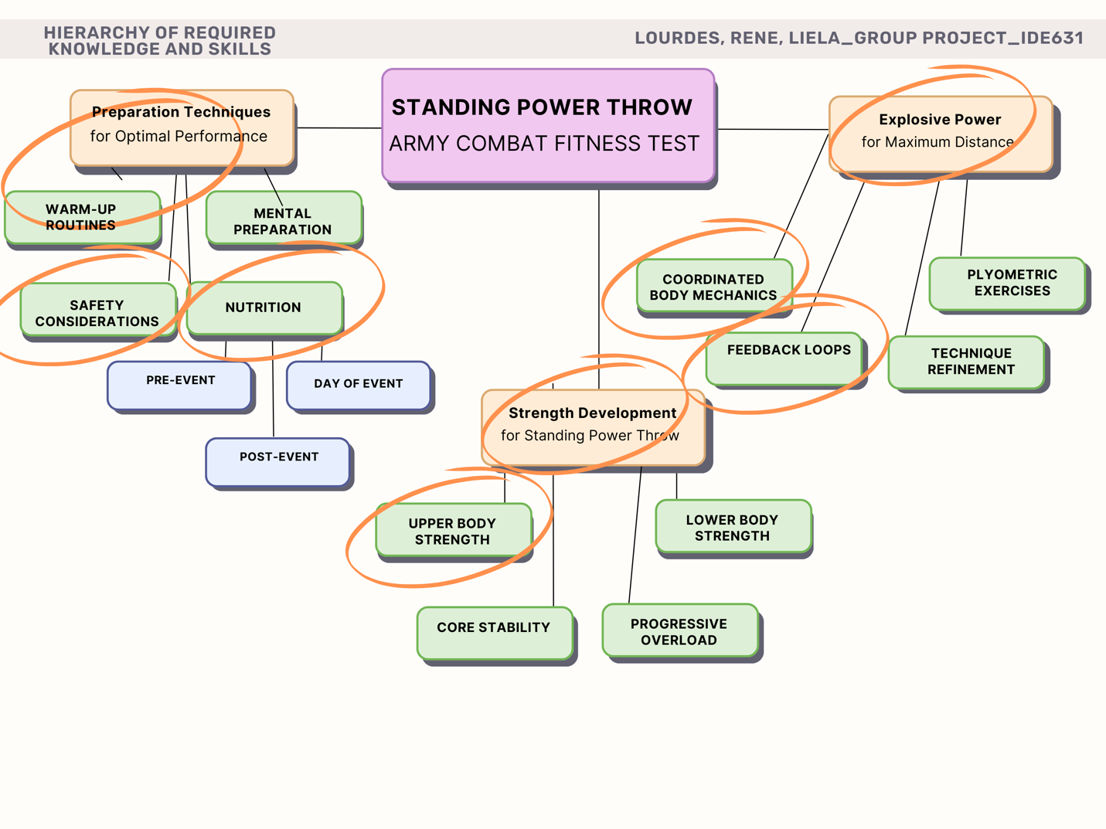

**Design-Content, Instructional Goals, Objectives, Assessments**

## Summarize Relationships among performance and content:

## Instructional Goals:

* **Develop Proper Body Mechanics and Technique for the Standing Power Throw:**  
  Facilitate soldiers’ understanding and execution of correct body mechanics, including coordination of the trunk, hips, and shoulders, to maximize throwing performance.
* **Build Strength to Support Explosive Movements:**  
  Provide structured training programs targeting lower body, upper body, and core strength, ensuring soldiers develop a solid foundation for explosive power.
* **Enhance Explosive Power Execution for Optimal Throwing Distance:**  
  Incorporate plyometric drills and explosive training techniques to improve soldiers' ability to generate force and achieve the minimum throwing distance required for the ACFT.
* **Promote Effective Nutrition and Hydration Strategies for Performance Optimization:**  
  Equip soldiers with practical knowledge about pre-event, day-of, and post-event nutrition and hydration to support peak physical performance during the ACFT.

## Learning Objectives:

* Cognitive Objective: Soldiers will be able to explain the importance of explosive power in the standing power throw and its relevance to military tasks.
* Psychomotor Objective: Soldiers will demonstrate proper technique for the standing power throw, ensuring safe and effective movement.
* Female soldiers between the ages of 18-24 will achieve a minimum score of 60-points in the standing power throw event of the ACFT will correct form.

## Summarize relationships among goals, objectives, and assessments

|  |  |  |
| --- | --- | --- |
| **Instructional Goal** | **Learning Objectives** | **Learning Assessment** |
| Facilitate soldiers' mastery of the Standing Power Throw, emphasizing proper preparation, strength development, and explosive power for operational tasks. | Soldiers will explain the importance of explosive power and its relevance to the Standing Power Throw event. | Multiple-choice quizzes will evaluate soldiers' understanding of explosive power and its impact on military performance. |
| Improve technique and performance, reducing the 15% failure rate among female soldiers aged 18-24, ensuring they meet ACFT standards. | Soldiers will demonstrate proper technique for the Standing Power Throw, ensuring safe and effective movements. | Practice assessments will require soldiers to perform the Standing Power Throw with correct form, scoring based on distance and execution aligned with ACFT standards. |
| Ensure soldiers are prepared physically and mentally, understanding the role of strength, nutrition, and hydration in the SPT event. | Soldiers will identify appropriate nutrition and hydration strategies to optimize their performance in the ACFT. | Written assignments and discussion activities will evaluate soldiers' ability to recommend pre- and post-event nutrition strategies. |
| Foster self-assessment skills and peer feedback to promote continuous improvement in performance. | Soldiers will accurately identify form deficiencies and provide constructive feedback during peer critiques. | Peer evaluations will assess soldiers' ability to critique each other’s performance, refining technique through collaborative feedback sessions. |

# Development: Storyboard Set

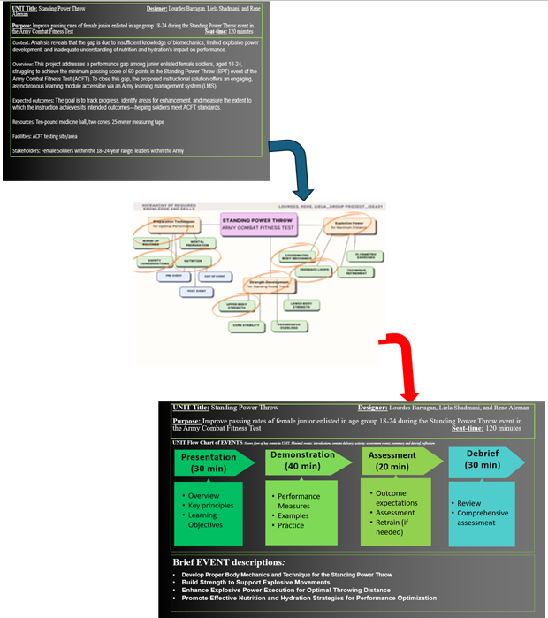

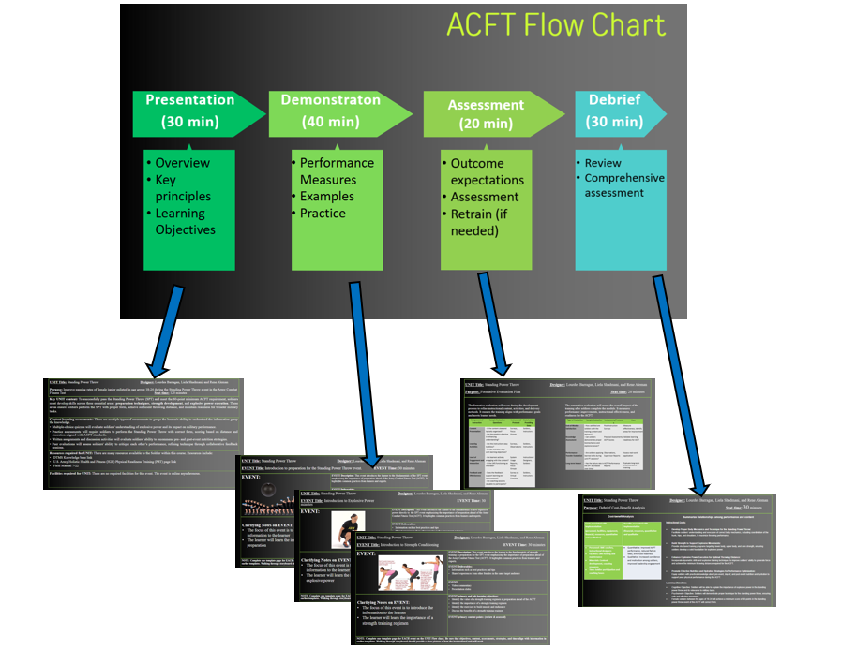

# Implementation: Dissemination Plan

The Standing Power Throw (SPT) instructional solution will be rolled out gradually on the Army's Learning Management System (LMS), which will let troops access the material at their own pace. The module will be provided 30 days before the Army Combat Fitness Test (ACFT) so that there is enough time to prepare. After the initial rollout, troops will be able to use the module whenever they want, which will help them practice and get better for future ACFT cycles. There will also be once-a-week virtual coaching sessions where you can get specific feedback on your technique, building your strength, and nutrition plans.

Many important people will be involved to make sure that the plan is adopted, and that people are interested in it. Squad leaders will lead the soldier through the process by supervising each soldier's involvement to make sure they understand the material and use it during practice. Using the LMS reporting tools, platoon sergeants will keep an eye on the general progress of the platoon. This enables the platoon level leadership to conduct one-on-one coaching sessions for soldiers who need specific training solutions. Leaders of platoons will work closely with platoon sergeants to set goals for success and make sure they are in line with the training goals for the whole unit. At the company level, the first sergeant will manage the process and ensure all platoons follow the rules and participate, and he or she will also deal with any problems that come up during the rollout. Company commanders will oversee the big picture. They will make sure that the instructional answer fits with the operational readiness goals and let subordinate leaders know what is expected of them.

Digital logbooks and a virtual scorecard will be used as part of engagement strategies to promote healthy competition and help people keep track of their own progress. Soldiers who consistently show up and work hard will be praised during unit meetings, which will motivate them even more. Soldiers will be put through physical training tests where they can use the skills they've learned after finishing the lesson. Squad leaders and platoon sergeants will provide feedback during these sessions to ensure knowledge transfer from the LMS module to real-world performance.

Instructional designers will monitor the module’s effectiveness, collecting data to make updates and improvements based on user feedback. Technology support personnel will ensure smooth access to the LMS and address any technical challenges that arise. If limited internet access becomes a barrier in field environments, downloadable materials will be provided to allow soldiers to train offline. The module is also structured in short, 15–20-minute segments to accommodate busy training many troops are participating, and which soldiers need extra help with things like nutrition, techniques, practical exercises, and so on. A post-module poll will ask soldiers for their thoughts, which will be used to shape future updates and improvements. This plan makes sure that the teaching solution is managed correctly, and that everyone knows what their part is. The plan helps troops meet ACFT standards by getting squad leaders, platoon sergeants, platoon leaders, first sergeants, and company commanders involved. This improves both the soldier's individual performance and overall unit readiness.

# Evaluation: Formative and Summative Evaluation Plan, Cose Benefit

## Overall Evaluation Plan

The evaluation of the instructional solution for the Standing Power Throw (SPT) focuses on assessing the quality, effectiveness, and impact of the training. The plan integrates formative and summative evaluations to ensure continuous improvement throughout development and deployment. The goal is to track progress, identify areas for enhancement, and measure the extent to which the instruction achieves its intended outcomes—helping soldiers meet ACFT standards.

## Formative Evaluation Plan

The formative evaluation will occur during the development process to refine instructional content, activities, and delivery methods. It ensures the training aligns with performance goals and meets learner needs.

|  |  |  |  |
| --- | --- | --- | --- |
| **Component of Instruction** | **Sample Evaluation Questions** | **Instrument/Protocol** | **Stakeholders Providing Data** |
| **Content Presentation** | - Is the content clear and logically organized? - Are the graphics effective in enhancing understanding? | Surveys, Focus Groups | Soldiers, Instructors |
| **Learning Activities** | - Are the instructions easy to follow? - Do the activities align with learning objectives? | Surveys, Observations | Soldiers, Instructors |
| **Level of Engagement and Interaction** | - Are learners actively engaging with the content? - Is the LMS functioning as intended? | System Usage Reports, Focus Groups | Instructional Designers, Soldiers |
| **Feedback and Effectiveness** | - Does the feedback support learning and improvement? - Are coaching sessions valuable to participants? | Survey on Virtual Coaching | Soldiers, Instructors |

## Summative Evaluation

The summative evaluation will assess the overall impact of the training after soldiers complete the module. It measures performance improvements, instructional effectiveness, and readiness for the ACFT.

|  |  |  |  |
| --- | --- | --- | --- |
| **Type of Evaluation** | **Sample Evaluation** | **Instruments/Protocols** | **Uses** |
| **End-of-Module Satisfaction** | - How satisfied are soldiers with the training content and delivery? | Post-Instruction Surveys | Measure effectiveness, identify areas for improvement |
| **Knowledge Assessment** | - Can soldiers demonstrate proper biomechanics and explosive power? | Practical Assessments, ACFT Scores | Validate learning, readiness for ACFT |
| **Performance Transfer Evaluation** | - Are soldiers applying learned skills during unit PT sessions? | Observations, Supervisor Reports | Assess real-world application |
| **Long-term Impact** | - Has the failure rate in the SPT decreased over time? | ACFT Performance Reports | |  | | --- | | Evaluate long-term effectiveness of training | |

## Cost-benefit Analysis

|  |  |
| --- | --- |
| ‘Costs associated with implementation  (personnel, facilities, equipment, financial, resources, quantitative and qualitative) | Benefits associated with implementation  (financial, resources, quantitative and qualitative |
| * **Personnel:** SME coaches, instructional designers * **Facilities:** LMS hosting and maintenance * **Materials:** Content development, coaching resources * **Time:** Soldier participation and coaching hours | * **Quantitative:** Improved ACFT performance, reduced failure rates, enhanced readiness * **Qualitative:** Increased confidence and motivation among soldiers, improved leadership engagement |

# References

Army implements ACFT based on scores, RAND study, and Soldier feedback. (2022, March 22). www.army.mil. <https://www.army.mil/article/254936/army_implements_acft_based_on_scores_rand_study_and_soldier_feedback>

Baechle, T. R., & Earle, R. W. (2008). National strength & conditioning association (US). *Essentials of strength training and conditioning. Champaign, IL: Human*  *Kinetics*, 395-396.

Beynon, S. (2021, May 10). Nearly half of female soldiers still failing new army fitness test, while males pass easily. *Military.com*. <https://www.military.com/daily-news/2021/05/10/nearly-half-of-female-soldiers-still-failing-new-army-fitness-test-while-males-pass-easily.html>

BISHOP, P., CURETON, K., & COLLINS, M. (1987). Sex difference in muscular strength in equally trained men and women. *Ergonomics*, *30*(4), 675–687. https://doi.org/10.1080/00140138708969760

<https://www.tandfonline.com/doi/abs/10.1080/00140138708969760>

Campbell, B. (Ed.). (2013). *Sports nutrition: enhancing athletic performance*. CRC Press.

*Eating right will improve ACFT score, says Army dietitian*. (2019, October 23). www.army.mil. <https://www.army.mil/article/228421/eating_right_will_improve_acft_score_says_army_dietitian>

Fernández-Lázaro, D., et al., (2020). Modulation of exercise-induced muscle damage, inflammation, and oxidative markers by curcumin supplementation in a physically active population: a systematic review. *Nutrients*, *12*(2), 501.

George N.George N. (2024b, March 6). *Military PT Test (Physical Fitness Test) 2024*. Army PRT. <https://www.armyprt.com/physical-fitness-test/military-pt-test/>

Heartwick, C. K., & Ivanova, C. V. (2022, August 19). Maxing the ACFT: How to fuel your body for the test. *Army Times*. <https://www.armytimes.com/news/your-army/2019/10/28/maxing-the-acft-how-to-fuel-your-body-for-the-test/>

Kenney, W. L., Wilmore, J. H., & Costill, D. L. (2022). *Physiology of sport and exercise*. Human kinetics.

Liguori, G., & American College of Sports Medicine. (2020). *ACSM's guidelines for*  *exercise testing and prescription*. Lippincott Williams & Wilkins.

Smith, P. L., & Ragan, T. J. (2004). *Instructional design*. John Wiley & Sons.

Smith M, Turner D, Spencer C, Gist N, Ferreira S, Quigley K, Walsh T, Clark N, Boldt W, Espe J, Thomas DM. Body shape and performance on the US Army Combat Fitness Test: Insights from a 3D body image scanner. PLoS One. 2023 May 3;18(5):e0283566. doi: 10.1371/journal.pone.0283566. PMID: 37134066; PMCID: PMC10155989.

# Appendix A

## [Links to Standing Power Throw Videos](https://sumailsyr.sharepoint.com/sites/3Amigos374/Shared%20Documents/Forms/AllItems.aspx?csf=1&web=1&e=nFvL8m&CID=e2c91269%2D1fcc%2D4474%2D97d9%2Dea8191d01802&FolderCTID=0x012000792EF607C327684C81F8F9BE17D8E8C8&id=%2Fsites%2F3Amigos374%2FShared%20Documents%2FGeneral%2FVideos)

# Appendix B

## [Link to Storyboard](https://sumailsyr.sharepoint.com/:p:/s/3Amigos374/EaZj_4KrnapKpBrN1CUXMXMB2qTWF8-VZ1hIbVtY7otX6Q?e=bWMv87)

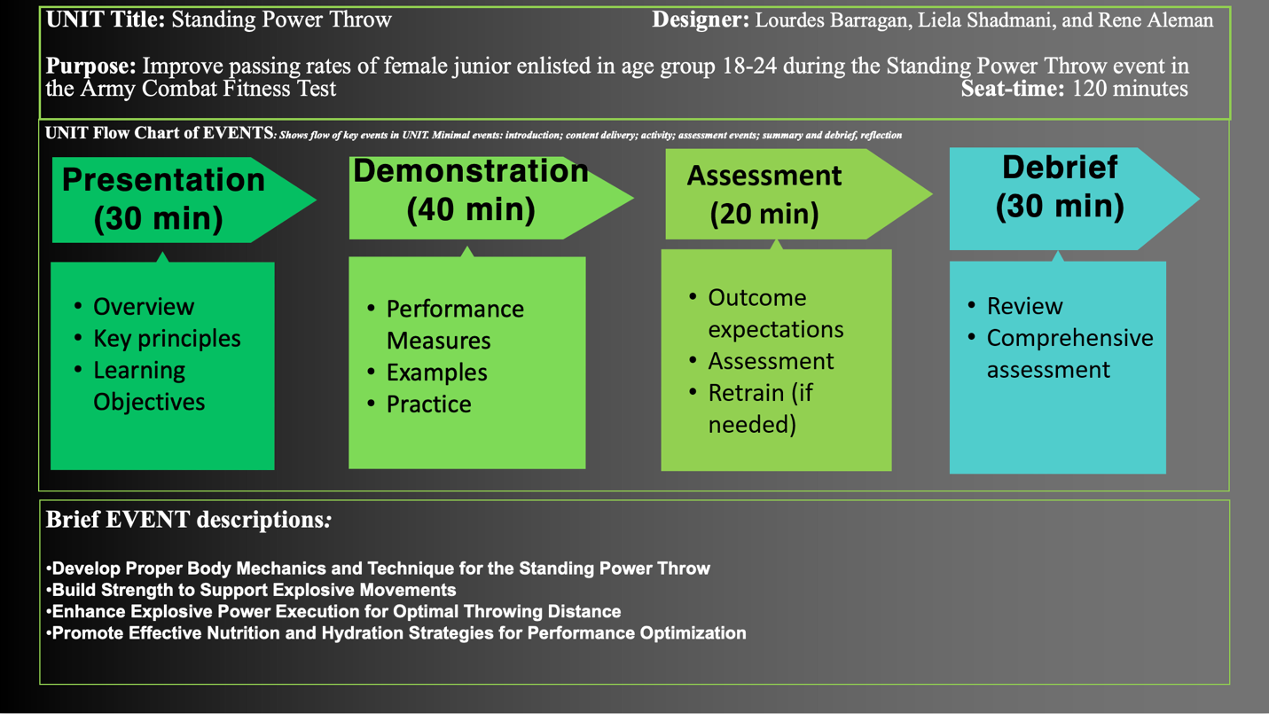

# Appendix C

## [Link to PowerPoint Presentation](https://youtu.be/_4BUGq6q200)

[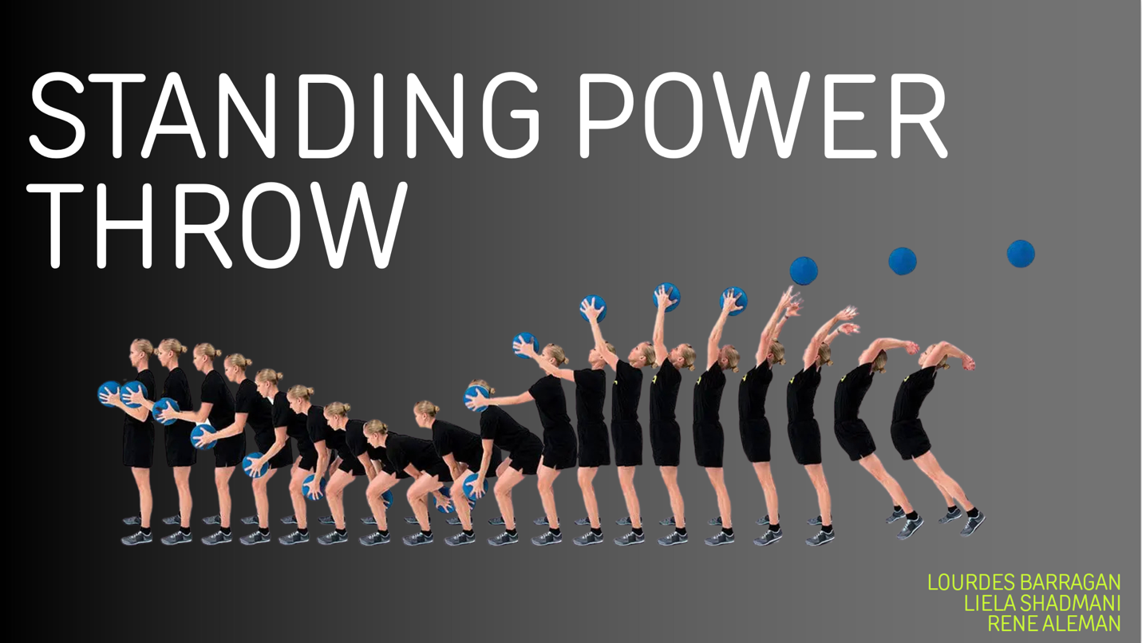](https://youtu.be/_4BUGq6q200)